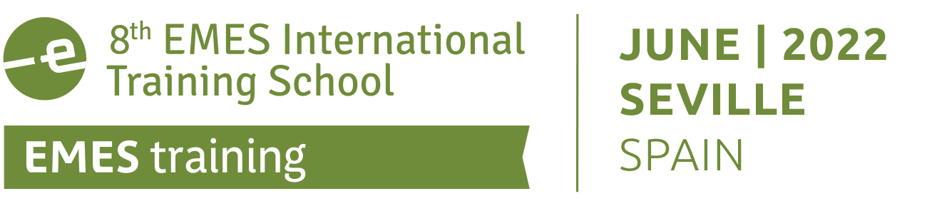

8th EMES INTERNATIONAL TRAINING SCHOOL

The key role of social enterprises and the social and solidarity economy in post-pandemic societies

20 – 23 June 2021 · Seville, Spain

Organised by:

APPLICATION FORM – PhD CANDIDATES

INSTRUCTIONS (please read carefully):
Applications to the 8th EMES International Training School will be assessed on the basis of the information provided in this form, which contains three sections. We therefore advise you to complete this form thoroughly. Please provide the required details but do not include any additional document.
In sections 2.5 and 2.6, please respect the word limits set. If needed, we may request you to provide documents proving any information included in this application.
The completed application form should be submitted as A SINGLE Word or PDF document by e-mail, with “8th EMES Training School” as subject line.
Email: 8EMEStrainingschool@emes.net
Application deadline //NEW DATE//: 4th March 2022

Section 1: PERSONAL DETAILS (IN BLOCK LETTERS, PLEASE)

Title | Family Name/Last Name:

Given Name/First Name: | Male/Female

Date of birth (day/month/year): | Nationality: | Special needs (i.e. dietary or mobility requirements):

Correspondence address: | Email address:
 | Telephone number (with international code):

IN CASE OF EMERGENCY PLEASE CONTACT
Name
Street / Street No
Postal Code / City / Country
Tel. / Fax / Email

Section 2: GENERAL AND ACADEMIC INFORMATION

2.1. HOW DID YOU LEARD ABOUT THE 8th EMES INTERNATIONAL TRAINING SCHOOL?

EMES Web and News Alert  Direct contact EMES or GCU-YC  University | Friends/Previous students/Colleagues  Other (please specify):  _________________________________

2.2. CURRENT UNIVERSITY
University name
Department/School
Address
Research area(s)
Year of study
Thesis advisor

2.3. SUMMARY OF EDUCATIONAL BACKGROUND
 | Degree type | Field(s) | Result | Date of award
UNDERGRADUATE
GRADUATE

2.4. ACADEMIC CURRICULUM VITAE
(Please insert the necessary text here – Do not send a different document. Max. 1500 words)

2.5. THESIS PROJECT DESCRIPTION
(Please provide a summary of your research project including a problem statement and research questions, theoretical framework, research methodology, and expected contributions: 1300-1500 words)

2.6. THESIS STATE OF ADVANCEMENT
(Please explain where you are currently with regard to the plan stated above: have the research questions and review of literature been achieved? What about the collection and treatment of data? Any preliminary conclusions? 500-700 words)

2.7. MOTIVATION LETTER
(Please explain why you are interested in participating in this training school and what you expect from it: 300-500 words)

Section 3: ADDITIONAL INFORMATION

3.1. REGISTRATION OPTIONS

The 8th EMES Training School offers four registration options, depending on whether the participant is a member of EMES and whether s/he is coming from non-OECD countries from Africa, Asia and Latin America:

Fees | EMES Members | Non-EMES members
Full registration | 375€ | 450€
Reduced registration type 1 (ITC & NNC countries) | 75€ | 245€

The registration cost covers registration fees, coffee breaks, lunches and one dinner. Travel, accommodation and rest of meals are to be covered by the participant. The organizers will provide a list of affordable accommodation options (including student housing).

3.2. GRANT OPTIONS

Depending on the availability of available funding, we may be able to offer additional grants.

A | If available, I would be interested in receiving some financial support.
B | I do not require financial support.

Should you need financial assistance to participate in the training school, please think about possible funders near you. In addition to your university department, you could try local foundations or research institutes.
Keep in mind that you may need to be creative and proactive and that we can support you with a support letter to support your funding request.

The working language of the Training School will be English.

By signing this document, I hereby certify that the information provided in this application form is accurate.

Date and place: Signature:

PLEASE RETURN THIS FORM BY 4th MARCH 2022
via email at 8EMEStrainingschool@emes.net

IMPORTANT DATES:
Application submission deadline: 4th March 2022
Results of the selection process: 18th March 2022
Registration deadline: 13th May 2022
Arrival of participants: 20nd June 2022

