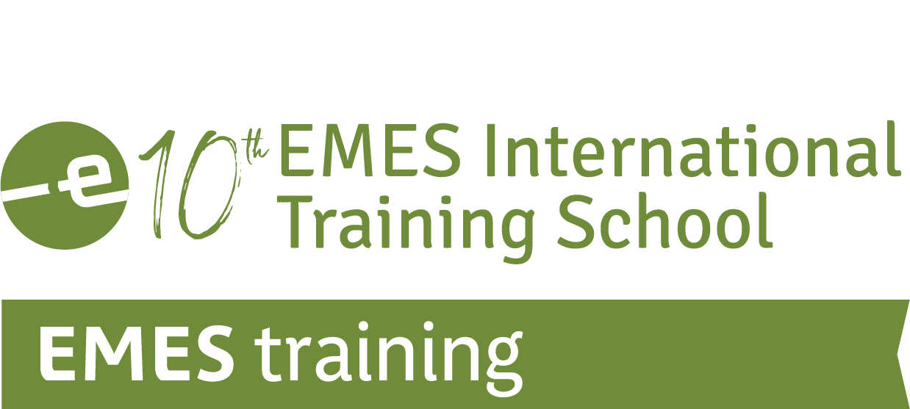

Advancing Knowledge and Driving Change:
What Epistemologies and Methodologies for Engaged Research in the SE Field in Times of Multidimensional Crises

APPLICATION FORM
FOR DOCTORAL CANDIDATES (PhDs)

29th June – 2nd July 2026 | Louvain-la-Neuve, UCLouvain & ULiège, Belgium

Co-organised by



Sponsored by


INSTRUCTIONS (please read carefully):
Applications to the 10th EMES International Training School will be assessed on the basis of the information provided in this form, which contains three sections. We therefore advise you to complete this form thoroughly. Please provide the required details but do not include any additional document.
In sections 2.5 and 2.6, please respect the word limits set. If needed, we may request you to provide documents proving any information included in this application.
The completed application form should be submitted as A SINGLE Word or PDF document by e-mail, with “10th EMES Training School” as subject line.
Email: 10EMEStraining@emes.net
Application deadline: 20th February 2026

Section 1: PERSONAL DETAILS (IN BLOCK LETTERS, PLEASE)

Title | Family Name/Last Name:

Given Name/First Name: | Male/Female

Date of birth (day/month/year): | Nationality: | Special needs (i.e. dietary or mobility requirements):

Correspondence address: | Email address:
Correspondence address: | Telephone number (with international code):

IN CASE OF EMERGENCY PLEASE CONTACT
Name
Street / Street No
Postal Code / City / Country
Tel. / Fax / Email

Section 2: GENERAL AND ACADEMIC INFORMATION

2.1. HOW DID YOU LEARD ABOUT THE 9th EMES INTERNATIONAL TRAINING SCHOOL?

EMES Web and News Alert  Direct contact (EMES, EURICSE, ESIC, Unitn)  University | Friends/Previous students/Colleagues  Other (please specify):  _________________________________

2.2. CURRENT UNIVERSITY
University name
Department/School
Address
Research area(s)
Year of study
Thesis advisor

2.3. SUMMARY OF EDUCATIONAL BACKGROUND
 | Degree type | Field(s) | Result | Date of award
UNDERGRADUATE
GRADUATE

2.4. ACADEMIC CURRICULUM VITAE
(Please insert the necessary text here – Do not send a different document. Max. 1500 words)

2.5. THESIS PROJECT DESCRIPTION
(Please provide a summary of your research project including a problem statement and research questions, theoretical framework, research methodology, and expected contributions: 1300-1500 words)

2.6. THESIS STATE OF ADVANCEMENT
(Please explain where you are currently with regard to the plan stated above: have the research questions and review of literature been achieved? What about the collection and treatment of data? Any preliminary conclusions? 500-700 words)

2.7. MOTIVATION LETTER
(Please explain why you are interested in participating in this training school and what you expect from it: 300-500 words)

Section 3: REGISTRATION INFORMATION

3.1. REGISTRATION OPTIONS
The 10th EMES Training School offers four registration options, depending on whether the participant is a member of EMES and whether s/he is coming from non-OECD countries from Africa, Asia and Latin America. Please let us know which option you’ll be choosing if your application is accepted:

Registration fees | EMES member * | Non-EMES member
Full registration | 400€ | 500€
Reduced registration ** | 100€ | 200€
* Participants registering under this fee will need to provide proof of membership (username). If you are not an EMES member and would like to join, you can do so directly on-line here (please select the “Graduate membership” fee).
** Reduced registration is available for applicants coming from universities located in non-OECD countries in Africa, Asia and Latin America and for applicants facing funding issues.

3.2. GRANT OPTIONS

We are working to be able to offer some limited grant support. It will be very helpful for us to know whether you count on funding to participate in this training school or require support in order to participate.

A | If available, I would be interested in receiving scholarship support to cover travel and related costs.
B | If available, I would be interested in receiving a registration fee waiver.
C | I do not require financial support.

Should you need financial assistance to participate in the training school, please think about possible funders near you. In addition to your university department, you could try local foundations or research institutes.
Keep in mind that you may need to be creative and proactive and that we can support you with a support letter to support your funding request.

The working language of the Training School will be English.

By signing this document, I hereby certify that the information provided in this application form is accurate.

Date and place: Signature:

PLEASE RETURN THIS FORM IN PDF FORMAT BY 20th FEBRUARY 2026
via email at 10EMEStraining@emes.net

IMPORTANT DATES:
Application submission deadline: 20th February 2024
Results of the selection process: 20th March 2026
Opening of registration platform: 20th March 2026
Registration deadline: 29th May 2026
Arrival of participants: 29th June 2026

